AIM: Understand the working of networking devices.
TOOLS/SOFTWARES REQUIRED: Cisco Packet tracer
THEORY:
Network hardware is a set of physical or network devices that are essential for interaction and communication between hardware units operational on a computer network
These are dedicated hardware components that connect to each other and enable a network to function effectively and efficiently.
HUB:
A hub is a simple networking device used to connect multiple computers in a local area network. When a data packet is received on one port, the hub broadcasts it to all other connected ports. It does not perform any filtering or address checking, which leads to more network traffic. A hub operates at the Physical Layer (Layer 1) of the OSI model.
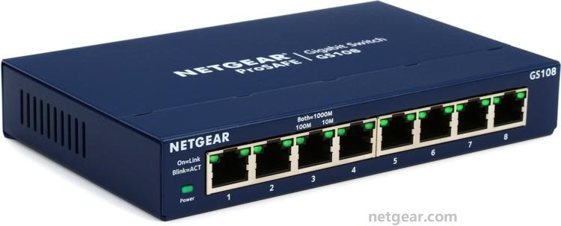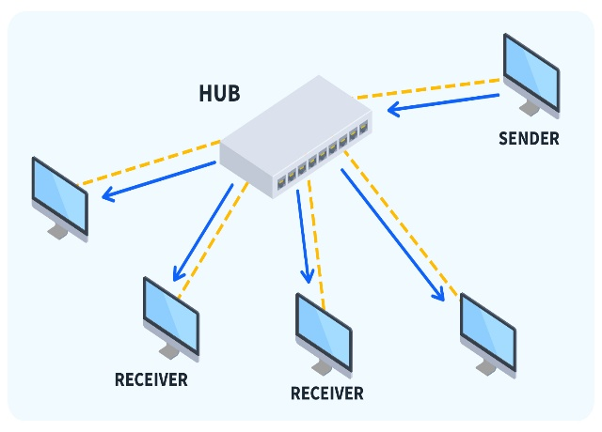

Switch:
A switch is an intelligent networking device that connects devices within a LAN and forwards data only to the intended recipient. It uses MAC addresses to identify devices and maintains a MAC address table to reduce unnecessary data transmission. This minimizes collisions and improves network performance. A switch works at the Data Link Layer (Layer 2) of the OSI model.
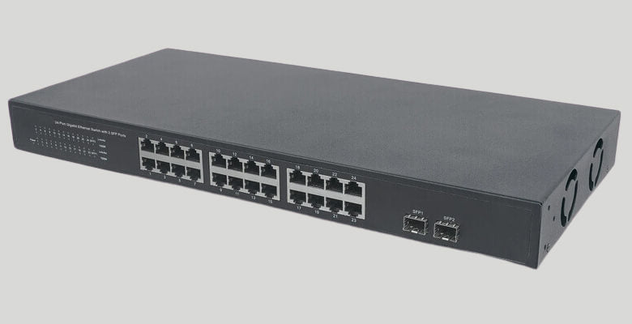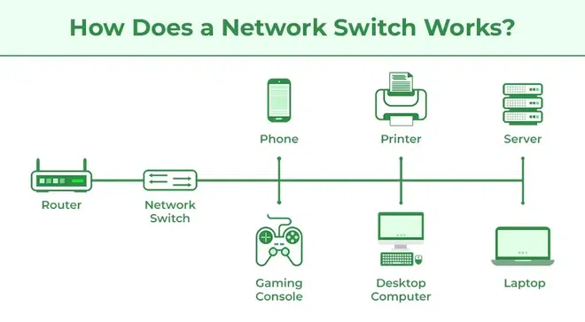

Router:
A router is a networking device used to connect two or more different networks. It forwards data packets based on IP addresses and routing tables, selecting the most efficient path for data transmission. Routers are commonly used to connect a local network to the internet and can also provide security features such as firewalls. A router operates at the Network Layer (Layer 3).
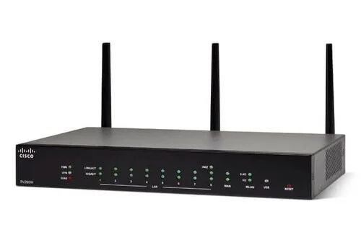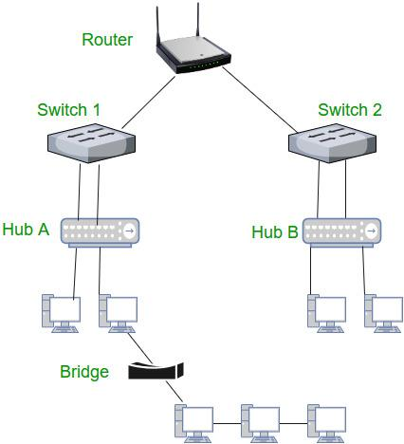

Bridge:
A bridge is used to divide a large local area network into smaller segments to reduce congestion. It filters data frames based on MAC addresses and decides whether to forward or block the data. By reducing unnecessary traffic, a bridge improves network performance. It operates at the Data Link Layer (Layer 2).
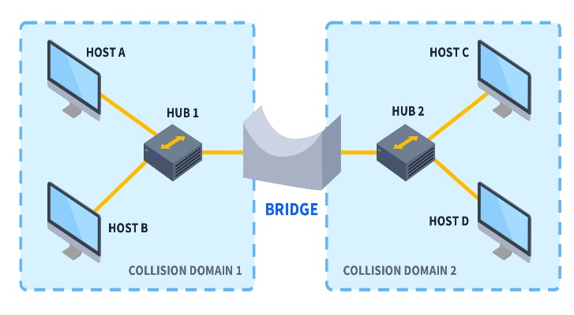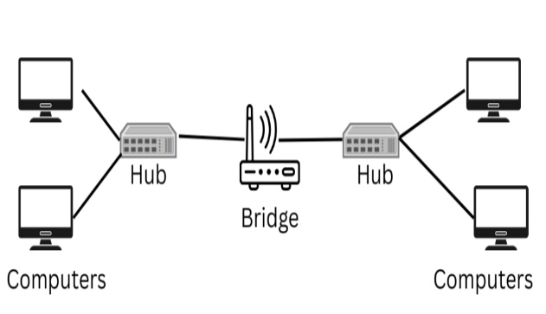

Gateway:
A gateway is a networking device that connects networks using different communication protocols. It performs protocol conversion so that data from one network can be understood by another. Gateways act as access points between dissimilar networks and are often used in complex network environments. A gateway can operate at multiple layers of the OSI model.
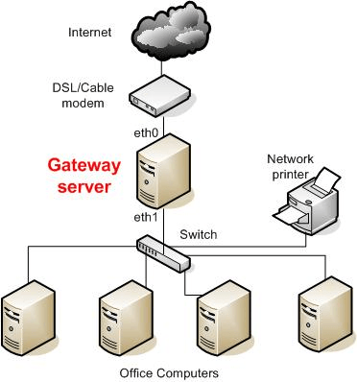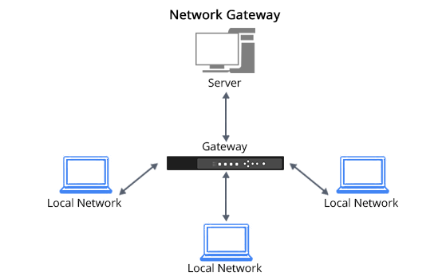

Repeater:
A repeater is a network device used to extend the physical distance of a network. It receives weak or degraded signals, regenerates them, and retransmits them to maintain signal strength. Repeaters do not process or filter data; they only deal with signal transmission. A repeater works at the Physical Layer (Layer 1).
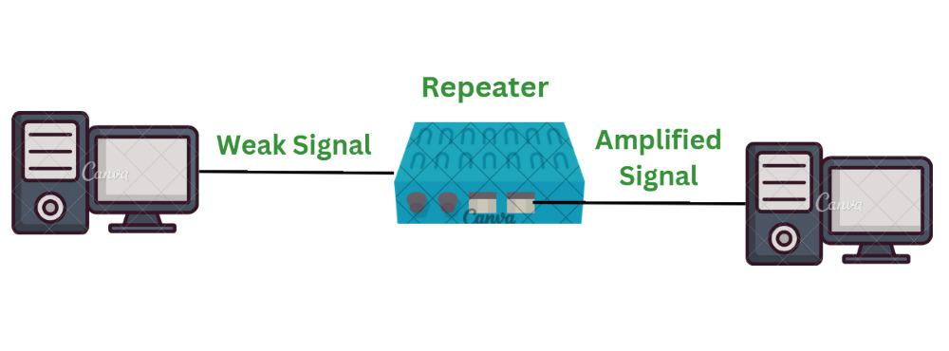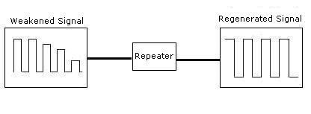

TOPOLOGIES:
Bus Topology
In bus topology, all devices are connected to a single common cable called the backbone. Data is transmitted in both directions along the cable. Failure of the main cable can stop the entire network.
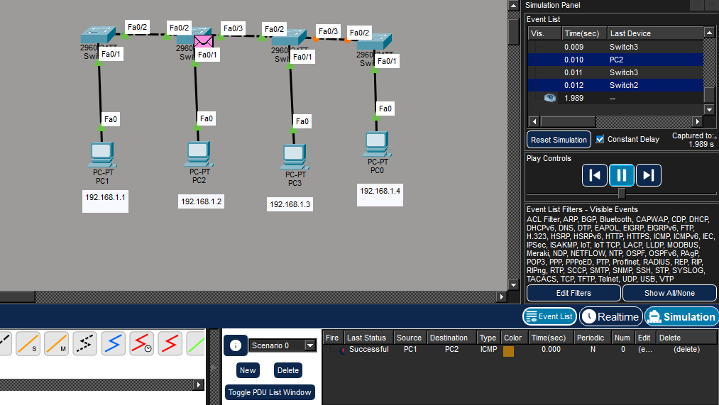
Star Topology
In star topology, all devices are connected to a central device such as a hub or switch. Data passes through the central device before reaching the destination. It is easy to manage and troubleshoot.
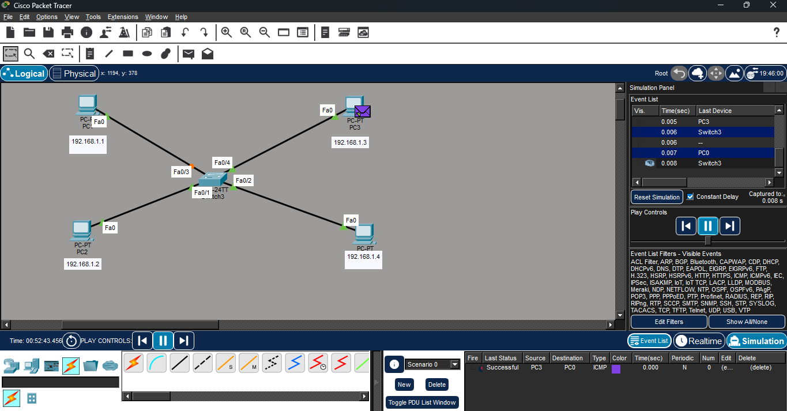

Ring Topology
In ring topology, each device is connected to exactly two other devices, forming a circular path. Data travels in one direction from one node to another. Failure of one node can affect the whole network.
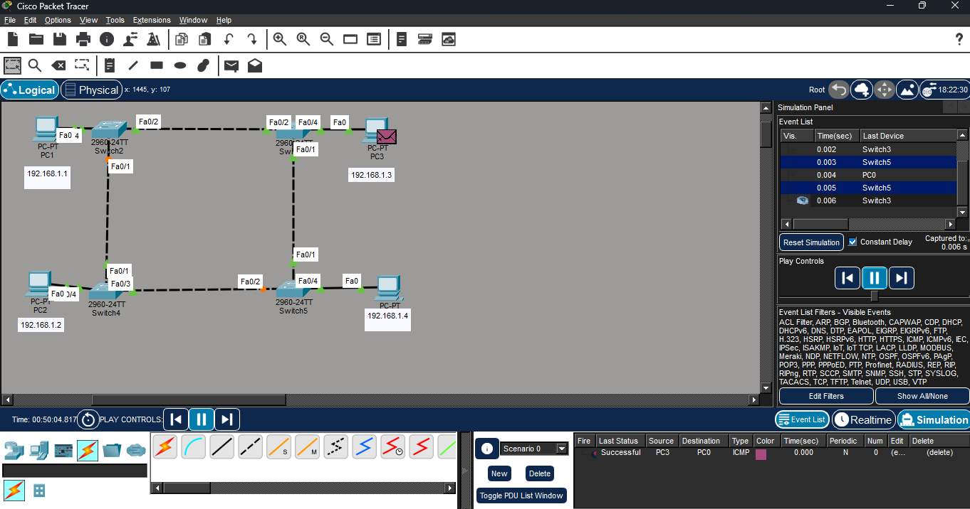

Mesh Topology
In mesh topology, each device is connected to every other device in the network. This provides high reliability and fault tolerance. However, it is expensive and complex to implement.
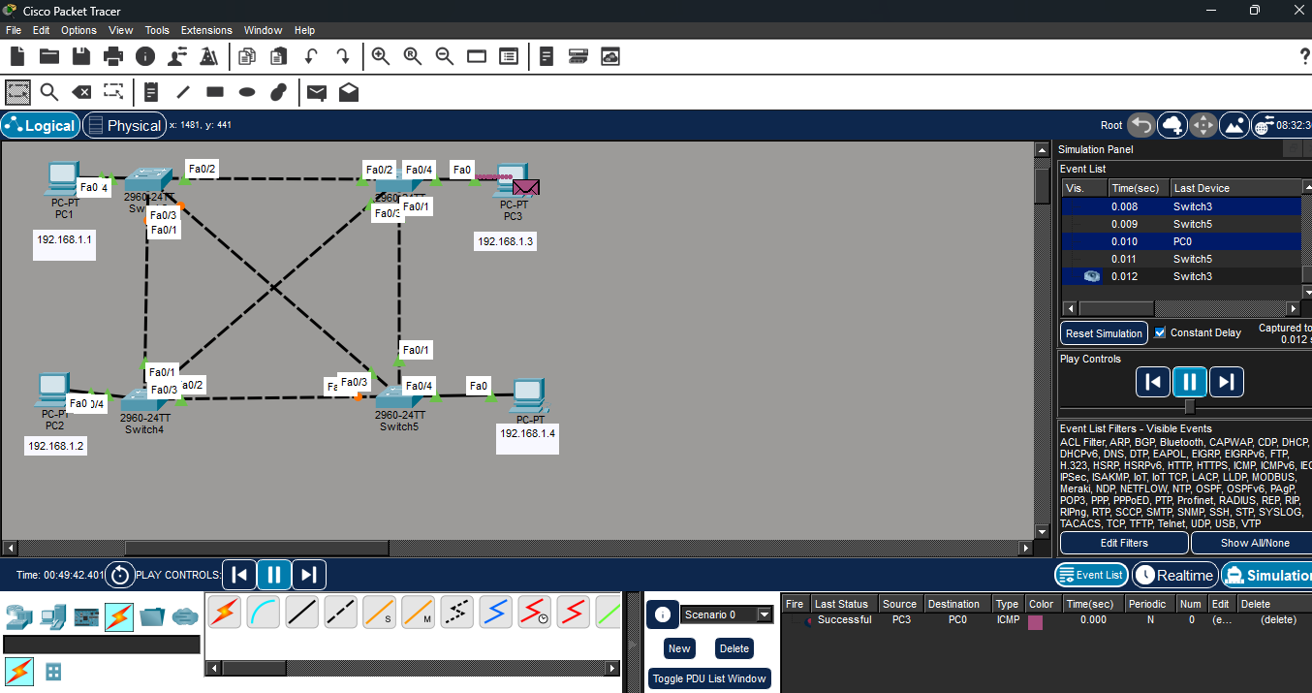

CONCLUSION:
In this experiment, we studied various network devices and network topologies and understood their roles in data communication. Each device and topology serves a specific purpose in building efficient and reliable networks. Proper selection of devices and topologies helps in improving network performance, scalability, and reliability.

